INSTRUCTIONS: This is an SOP template; it is complete when
1) All form fields have been completed to reflect chemical/lab-specific information, including adding relevant procedure information, or deleted inapplicable information; and
2) SOP has been signed and dated by the PI and relevant lab personnel.
Use safety data sheets (SDSs) as a resource for chemical-specific information. Text highlighted in gray indicates where information should be added or edited. Delete all instructions in red text and “Draft” watermark after the SOP is approved by PI.
Standard Operating Procedure
Cyclosporin A
Print a copy and insert into your Lab-Specific Chemical Hygiene Plan.
Section 1 – Lab-Specific Information
Building/Room(s) covered by this SOP:
Unit or department:
Principal Investigator Name:
Principal Investigator Signature/Date:
This SOP was created by (if not PI):
Name/Title/Date/Signature:

Section 2 – Hazards
Cyclosporin A (also known as cyclosporine) is a potent immunosuppressant that may be harmful if ingested, inhaled, or absorbed through the skin. It may cause irritation to the gastrointestinal tract, respiratory tract, skin, and eyes. It may cause adverse reproductive effects including damage to fertility and the unborn child. It is classified by IARC as Group 1, carcinogenic to humans. Cyclosporin A is mainly used as an immunosuppressant drug to inhibit rejection of transplant organs. It is also used to treat a wide range of diseases known to have immunological factors in their pathogenesis.
Symptoms of exposure include nausea, vomiting, tremors, elevated blood pressure, convulsions, metabolic changes, cardiovascular changes, and diarrhea. May cause adverse liver and kidney effects.
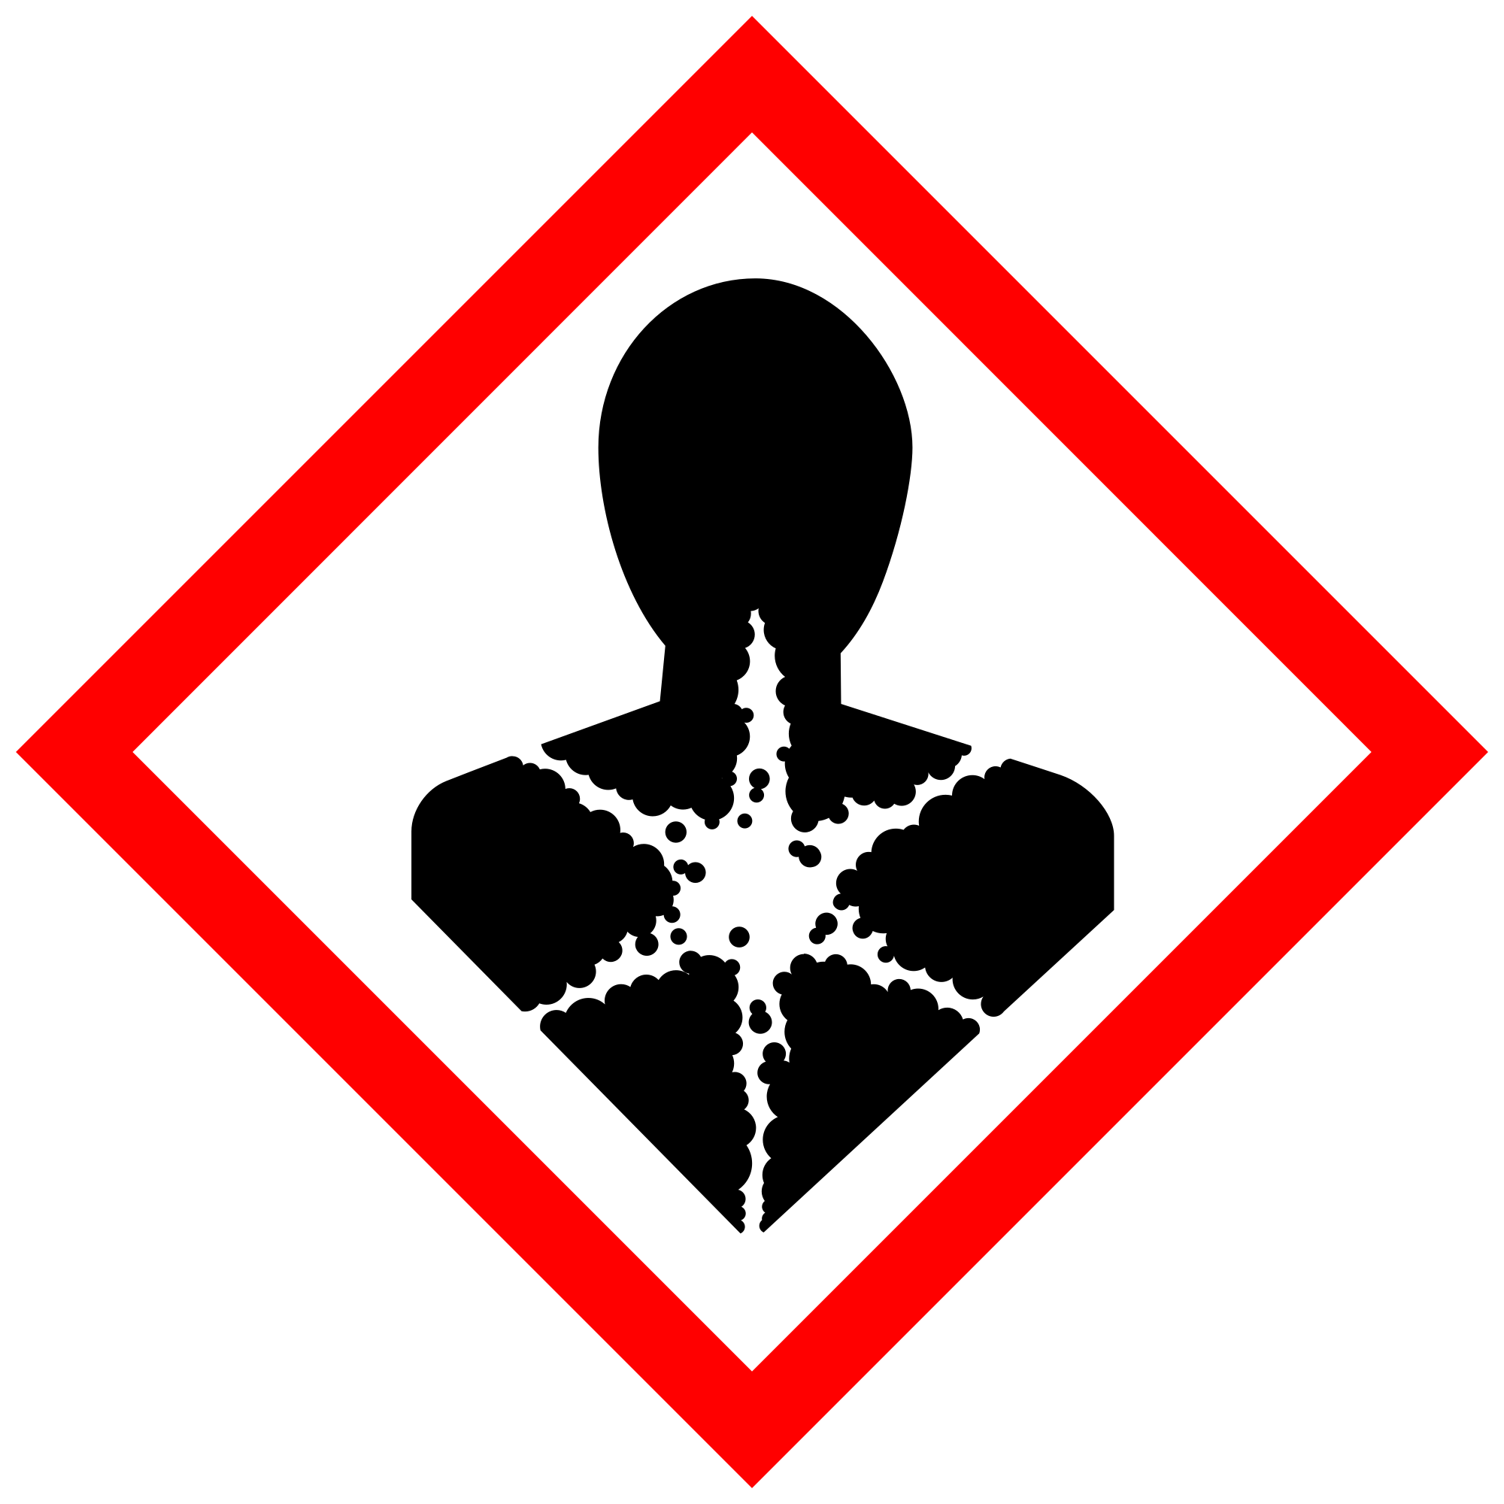
Section 3 – Engineering and Personal Protective Equipment (PPE)
Engineering Controls: The use of cyclosporin A should be conducted in a properly functioning chemical fume hood whenever possible. The chemical fume hood must be approved and certified by EH&S.
Hygiene Measures: Avoid contact with skin, eyes, and clothing. Wash hands before breaks and immediately after handling the chemical.
Hand Protection: Chemical-resistant gloves must be worn, nitrile gloves are recommended. Wearing two pairs of nitrile gloves is recommended. NOTE: Consult with your preferred glove manufacturer to ensure that the gloves you plan on using are compatible with the specific chemical being used.
Eye Protection: ANSI-approved properly fitting safety glasses or chemical splash goggles are required.
Skin and Body Protection: Laboratory coats must be worn and be appropriately sized for the individual and buttoned to their full length. Personnel must also wear full length pants, or equivalent, and close-toed shoes. Full length pants and close-toed shoes must be worn at all times by all individuals that are occupying the laboratory area. The area of skin between the shoe and ankle must not be exposed.
Respiratory Protection: Respirators should be used as a last line of defense (i.e., after engineering and administrative controls have been exhausted), and when Permissible Exposure Limit (PEL) has been exceeded or when there is a possibility that PEL will be exceeded. If this activity is necessary, contact EH&S at 206.543.7388 so a respiratory protection analysis can be performed. Use a full-face particle respirator with type N100 (US) respirator cartridges.
Section 4 – Special Handling and Storage Requirements
- Avoid contact with skin, eyes, and inhalation.
- Avoid dust formation.
- Keep containers tightly closed. Store in a cool, dry, and well-ventilated area. Recommended storage temperature is 2-8’C.
- Keep away from incompatible substances such as oxidizing agents, alkali metals, and aluminum.
- Use in the smallest practical quantities for the experiment being performed.
- Work must be conducted in a properly functioning chemical fume hood.
- Containers should remain closed when not in use.
- Containers should be labeled appropriately. Label should indicate the name of the chemical(s) in the container. Avoid using chemical abbreviations and formulae.
- Containers should be in good condition and compatible with the material.

Section 5 – Spill and Accident Procedures
If skin is exposed to cyclosporin A, remove contaminated clothing and shoes, rinse for 15 minutes in the safety shower. Send someone to call 911 as soon as possible. If eye is exposed, call 911 as soon as possible and flush eyes for 15 minutes in the eye wash. If cyclosporin A is inhaled, remove to fresh air and call 911. Bring Safety Data Sheet (SDS) with you to show medical personnel.
Immediately evacuate area if fumes present a serious health risk or a spill occurs; ensure others are aware of the spill. Avoid breathing vapors. During normal business hours (Monday – Friday, 8 AM – 5 PM), call EH&S at 206.543.0467 for further assistance. If it is after hours, call 911 for further assistance. If possible, confine the spill to a small area using a spill kit or absorbent material. Keep others from entering contaminated area (e.g., use caution tape, barriers, etc.).
For spills < 1 Liter, use appropriate personal protective equipment listed above and clean-up material for chemical spilled. Double bag and securely fasten spill materials. Label as hazardous waste.
For spills > 1 Liter, call EH&S at 206.543.0467 for further assistance during normal business hours (Monday – Friday, 8 AM – 5 PM). If it is after hours, call 911 for further assistance.
Report the spill via the EH&S Online Accident Reporting System (OARS).
Section 6 – Waste Disposal Procedures
Store hazardous waste in closed containers that are properly labeled, and in a designated area. Decontaminate equipment and bench tops using soap and water. Sweep up spills to avoid dust formation. Request chemical waste collection via the EH&S website.

Section 7 – Protocol
Click here to enter text.
NOTE: Any deviation from this SOP requires approval from Principal Investigator.

Section 8 – Documentation of Training (signature of all users is required)
Prior to conducting any work with cyclosporin A, the Principal Investigator must ensure that all laboratory personnel receive training on the content of this SOP.

I have read and understand the content of this SOP:
Name | Signature | Date

